**Films Over the Last 100 Years**

**Data Analysis by:**

*Kevin Avery*

*Megan Foster*

*Meha Marathe*

*Troy Rippeto*

Who doesn’t love a good trip to the movies? There’s swashbuckling adventures to be had, dramatic capers to be solved, musical numbers to tap along with, and countless stories to immerse yourself in if you’ve got 90 minutes to spare. For our project, we thought it would be fun to look at movies over the past century and search for trends. And not just any movies, but the top grossing and Academy Award winning Best Picture films over the course of the last 100 years. What trends might we discover? And maybe more importantly what changes do we see? Are movies in the 21st Century different than what we had last millennium?

**Are there any trends in popular genres for being a top-grosser or best picture winner?**

The most popular genre for "Best Picture" films is Drama whilst the most popular genre for Top Grossing films is Action/Adventure.

**Does the length of the movie impact its appearance as a top-grosser or best picture winner?**

While not wildly different, the Best Picture film winners do run an average of almost 15 minutes longer than the Top Grossing films. What does this really mean? If you want to watch all 93 highest grossing films since 1927, you will need to clear your schedule for 190 hours and 47 minutes. To watch all 93 Best Picture Award Winners, you will need 214 hours and 35 minutes. Or an extra day (8 days vs. 9 days). Please note this does not include time allowances for eating or sleeping, so plan accordingly.)

**How are the best picture winners and top-grossers rated by popular users on sites such as “Rotten Tomatoes” or “IMDB”?**

Across the Internet Movie Data Base (IMDB), the ratings for top grossing films and best picture award winners are markedly similarly across the years with both pictures typically rating favorably. Meanwhile, the Rotten Tomato "Tomatometer" shows a greater variation between top grossing film scores and best picture film scores. Particularly of interest are the films from 2014. The Best Picture Winner, *Birdman*, rated over 90% whilst the Top Grossing Film, *Transformers: Revenge of the Fallen*, rated at a very unfavorable 20%. Overall, best picture films score consistently favorably on the Tomatometer, whilst the more volatile score swings belong to the top grossing films.

**How diverse are the main actors in a film from a racial perspective?**

From a racial perspective, it is evident that best picture films were more diverse than top grossing films, but it was by less than 10%. This goes to show that our film industry needs to become more inclusive on a racial scale. Additionally, for the first 4 decades of the film industry (in both categories), all main characters were white. Overall, it is clear that best picture films are more diverse but not by much.

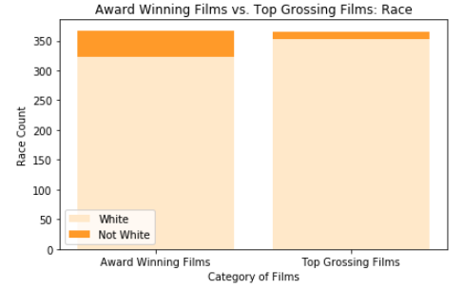

Overtime, non-white actor diversity has increased, but there is still much room for growth, especially when you look at the overall numbers and breakdown.

**Does one of the genders dominate the composition of main actors in a film?**

Yes. The male gender dominated the composition of main characters in both best picture films and top grossing films over the last 100 years. There is only a 1.2% difference between the two datasets, which goes to show that top films have been consistently male-dominated in terms of top-billed actors. There is a presence of women throughout the years but it is not as diverse as we had assumed.

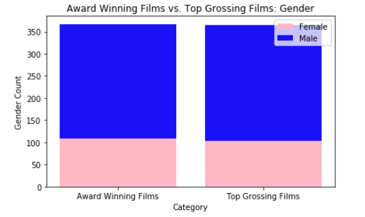

Interestingly, the trend for the inclusion of women in top films appears to be trending downward over the past century.

**Are there any trends in pass rates of the Bechdel test over the years?**

First, what exactly is the Bechdel Test? It’s a test applied to any type of fictional media output (book, movie, song, etc.) to measure the representation of women in the medium. So, how does a film pass the test:

* It must feature at least two women…
* who talk to each other…
* about something other than a man.

Easy. Right?

Just under half of both the Best Picture (45%) and Top Grossing films (42%) over the past century passed the Bechdel Test.

Has this changed over time? Maybe? Since the turn of the century twenty years ago, of the top grossing films for each year - 14 pass the Bechdel test. And of course the Best Picture Award winners have kept up with this trend, right? Well, not exactly. Since 2000, only 10 out of the 19 Academy Award Best Picture Winners pass the Bechdel Test. And at the turn of the millennium? Both the top grossing film (*Mission Impossible II*) and the Best Picture award winner (*Gladiator*) FAIL the Bechdel test with a ZERO. Which means, not only is there no conversation between two women in the film about something besides a man. The films fail to include two female characters at all.

